Electrical Safety Training Practice Test
1. What is the longest extension cord authorized for use at JJV (in feet)?

A. 50
SGOP-0022, page 20 section 11.8
B. 25
C. 125
D. 100

2. What is the minimum HRC PPE level for voltage testing in an uncalculated single phase 208 VAC control cabinet?
VWA-0839, page 1
A. AF PPE 1
B. AF PPE 4
C. AF PPE 0
D. Non-melting clothing

3. How would you obtain voltage rated gloves?
WSSI Electrical Safety in the workplace Power Point slide 15 “Rubber gloves are issued and returned to Spare Parts”
A. Cribmaster or Spare Parts
B. Contact EHS
C. Issued to all Green/Blue card associates
D. Not allowed at JJV

4. What information is not listed on an ARC Flash label?
Refer to ARC Flash Label: potential calculated ARC Flash energy level does not equal actual ARC Blast energy level
A. ARC Flash Boundary
B. Nominal Voltage
C. Restricted Approach Boundary
D. ARC Blast Energy Level

5. Electrical qualification is no longer required when working with live electrical circuits below what voltage?

A. 50
VWA-0839, page 1
last sentence
B. 120
C. 12
D. 24

6. Which of these steps is not part of the Job Hazard Analysis?
SGOP-0022, page 16 section 8.3
last sentence
A. Assessment of potential electric shock
B. Documenting completion of the Job Hazard Analysis
C. Determining ARC Flash boundaries
D. Determining shock protection boundaries

7. When would you not be required to verify a meter on a known good voltage source?
SGOP-0022, page 13 section 5.2.1
A. Prior to establishing electrical safe work area
B. After checking a panel for de-energized state while establishing an electrically safe work area
C. Prior to taking voltage readings in a live electrical cabinet
D. Annually

8. What is the minimum HRC PPE level for voltage testing in an uncalculated 208 VAC 3 phase, hard wired device?
VWA-0839, section A
DANGER, NO ENTRY ALLOWED

A. AF PPE 4
B. Non-melting clothing
C. No entry allowed
D. AF PPE 0

9. What is the minimum HRC PPE level for voltage testing in an uncalculated 120 VAC control cabinet?

A. AF PPE 1
VWA-0839, section A
B. AF PPE 0
C. Non-melting clothing
D. AF PPE 4

10. What is permitted in an electrical cabinet that has not been established as an electrically safe work area?

A. Un-insulated tools
VWA-0839, section A
B. Necklace
C. Non-conductive flashlight
D. Metal rimmed glasses

11. What is the minimum AWG extension cord that can be used at JJV?
SGOP-0022, page 16 section 8.2.7
A. 10
B. 12
C. 14
D. 16

12. Which meter listed is not authorized to establish an electrically safe work area?
SGOP-0022, page 13 section 5.2.1
A. TEGAM
B. Metrix MX 57-EX
C. Fluke T5
D. Fluke 87

13. Which of the following does not require semi-annual/annual inspection per SGOP-0022?
VWA-0836, under Insulated Tools section. Requires a visual inspection prior to use.
A. Insulated Tools
B. Voltage Rated Rubber Gloves
C. Personal shirt or lab coat meeting AF PPE 0 minimum requirements
D. TEGAM/Fluke T5

14. The Limited and Restricted approach boundaries are established for what hazard?

A. ARC Blast
SGOP-0022, page 2 sections 2.9 & 2.10
B. Shock
C. Fire
D. ARC Flash

15. What meter can you use to establish an electrically safe work area in a non-classified area?

A. Fluke T5
SGOP-0022, page 13 section 5.2.1
Fluke 77 & 87 cannot be used because test leads can be removed.
Non-intrinsically safe test equipment to be used on non-classified areas
B. Fluke 77
C. Fluke 87
D. Metrix MX 57-EX

16. What is the minimum HRC PPE level for voltage testing in an uncalculated 480 VAC 3 phase, hard wired device?
VWA-0839, section A
DANGER, NO ENTRY ALLOWED

A. AF PPE 4
B. Non-Melting clothing
C. No Entry Allowed
D. AF PPE 0

17. What meter can you use to establish an electrically safe work area in a classified area?

A. Fluke T5
SGOP-0022, page 17 section 9.3
Intrinsically safe equipment must be used in classified areas.
Classified areas are those that involve special operating conditions SGOP-0022 section 9.2

B. Metrix MX 57-EX
Intrinsically safe test equipment SGOP-0022 section 2.33 & 2.42
C. TEGAM
D. Fluke 87

18. When can an unqualified person cross the Restricted Approach boundary to a live electrical cabinet?

A. When wearing appropriate PPE and continuously escorted by a Blue Badge card holder
B. Electrically safe work area has been established
C. Never
D. When wearing appropriate PPE and continuously escorted by a Green Badge card holder
SGOP-0022, page 9 section 3.3.4.1

19. When can an unqualified person cross the Limited Approach boundary in a live electrical cabinet?
SGOP-0022, page 2 section 2.9
A. Never
B. Electrically safe work area has been established
C. When wearing appropriate PPE and constantly escorted by a Blue Badge card holder
D. When wearing appropriate PPE and constantly escorted by a Green Badge card holder

20. Which is not a special operating condition?
SGOP-0022, page 17 sections 9.1 & 9.2
Mezzanine Green grid is not listed as a special operating condition.
A. Yellow lighting
Considered special lighting. Will affect wire color perception
B. IPA Storage Area
C. Waste Plastic Area
D. Mezzanine Green grid

21. Under AF PPE 0, what must be true of the pants worn?
VWA-0839, section B
Arc Flash PPE Category 0 Minimum PPE
A. Intrinsically safe
B. Untreated Natural Fiber
C. ARC Rating of 4.0 Cal/CM 2
D. 4.5 oz/yd fabric

22. Which is not required per SGOP-0022 if there is a live component that is not finger touch protected and needs to be accessed?
SGOP-0022, page 9 section 3.3.4.1
First paragraph
A. Contractor: Journeyman or Master Electrician
B. Energized Work Permit
C. Voltage rated rubber gloves
D. Blue Badge card holder

23. Which would not require a Blue Badge inspection prior to restoration of power?

A. Replacement of 250V, 2A fuse
SGOP-0022, page 9 section 3.3.4.1
Last sentence
B. Replacement of a zone stop lamp
C. Replacement of a neutral wire lug in a 208 Volt motor
D. Replacement of a 208 Volt blower motor

24. Which is not PPE for AF PPE 0?
VWA-0839, page 2 section B
A. Safety glassed with side shields
B. EH rated shoes/boots
C. Hearing protection
D. 4 Cal/CM2 rated lab coat or long sleeve shirt

25. What is the minimum burn level that constitutes a non-recoverable injury?
SGOP-0022, page 2 section 2.8
A. 3rd Degree
B. 2nd Degree
C. 4th Degree
D. 1st Degree

26. Which of the following would require PPE to operate a fuse or disconnect?

A. Initial power up after major electrical repair completed
B. Equipment PM program is current
C. Equipment in good operating condition
D. Cabinet secured properly

27. In a 120 VAC panel, which is not considered electrical work?

A. Tightening a loose contact block screw
B. Replacing a fuse in an IP 20 rated fuse holder
C. Removing wire way coves to trace wiring
D. Taking current reading on the primary side of a transformer with a non-clamp on Amp meter

28. When is electrical PPE required?

A. Working on a 48-volt proximity sensor
B. Operating a disconnect with the door secured and the equipment is in known good condition
C. Opening door to a live electrical cabinet
D. No ARC Flash label and highest voltage is 120V

29. What is the energy level at which a non-curable burn will occur?
SGOP-0022, page 2 section 2.8

A. 2.1 Cal/CM2
B. 1.2 Cal/CM2
C. 4 Cal/CM2
D. 40 Cal/CM2

30. What is permitted in a 50 VAC or greater electrical cabinet prior to establishing an electrically safe work area?
FLUKE 80 series are approved for use IAW VWA-0835 Sec III
A. “Tweaker”, if only to be used on 48V or less
B. Metal rim glasses under safety glasses
C. Fluke 87
D. Necklace under an ARC rated shirt

31. Which is not part of a Job Hazard Analysis?
SGOP-0022 pages 15-16 sections 8.1 & 8.2
A. Determine means to restrict access
B. Ensure compliance with VCF-1816
C. Determine PPE to be used
D. Assessing for special operating conditions

32. Which step is not part of establishing an electrically safe work area?
SGOP-0022 pages 13-14 section 5.0
A. Check each conductor phase to phase
B. Check meter lead resistance
C. Apply lock and tag
D. Check each conductor phase to ground

- Per SGOP-0022 electrical troubleshooting, which of the items below would not fall under a special operating condition?
  - Wet Location
SGOP-0022, page 17 section 9.0 does not list 600VAC panel as a special operating condition.
  - 600VAC Electrical Panel
  - Yellow Lighting
  - Chemical Storage Area

- PPE must be inspected by the user for defects:
  - Every 6 months
SGOP-0022, page 16 section 8.9
  - Annually
  - Before each use

- Which are the three main hazards of electricity IAW NFPA-70E?
  - Shock, Arc Blast, Fire

  - Shock, Arc Flash, Arc Blast
  - Arc Flash, Fire, Explosion
  - Blast, Fire, Explosion

- Only __________ persons are allowed to work on or near energized circuits or parts.
  - Unqualified
SGOP-0022, page 14 section 7.1
  - Trained
  - Qualified
  - Self-aware

- The following steps have been performed:
    - Personal Lock and Tag applied in accordance with the applicable HECP.
    - TEGAM or T5 Tester was used.
    - Above meter is verified operating correctly on a known voltage source.
    - Circuit verified de-energized by checking each conductor phase to phase and phase to ground.
    - Top of the “Main Disconnect” is “Finger Touch” protected.

Has an electrically safe work area been established?
SGOP-0022, page 13 section 5.2.1
Note: missing step to verify proper meter operation after use.
- Yes
- No

- OSHA required that live parts to which an employee may be exposed to, shall be _____ before work is performed on or near them.
  - De-energized
OSHA 29 CFR Part 1910
1910.333.(a)(1) – Live parts to which an employee may be exposed shall be de-energized before the employee works on or near them.
Note: found in one of the Power Point presentations
  - Illuminated
  - Identified
  - Energized

- It is generally accepted that an arc flash exposure of 1.2 cal/cm² contains enough heat to cause the onset of a 2nd degree burn and is recognized by NFPA 70E as the point where arc flash protective clothing and equipment is required. How can you determine if a device in an electrical panel could expose you to 1.2 cal/cm² or grater?
  - Train to equipment specific Hazardous Energy Control Procedure (HECP)
  - If you remain at least 36 inches from the device, the discharge energy will always be lower than 1.2 cal/cm².
  - Read the arc flash label.

  - Refer to the current edition of NFPA 70E Table 130.7(D)(4)(a.).

- The Arc Flash boundary distances can be found in:
  - NFPA 70 (NEC)

  - NFPA 70 E
  - OSHA 1910
  - Both a & b
  - All three (a, b, c)

- Which of the following requires a Blue Card to perform or inspect prior to re-energizing?
  - Replacement of a servo motor with quick disconnect.
SGOP-0022, page 10 section 3.3.4.2
  - Thermal imaging of open energized electrical cabinet.
  - Replacement of a burned ballast with a melted quick disconnect.
  - Troubleshooting blown 480VAC fuse.

- For the Arc Flash Label, at what distance from the exposed electrical hazard is PPE required? 42”
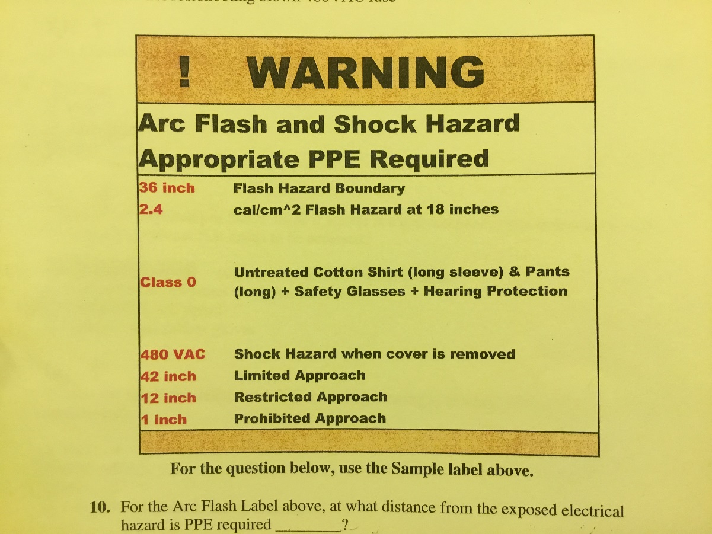

- What is the minimum HRC level PPE for resetting a breaker?
  - No PPE required.
  - HRC-1
VWA-0839
  - HRC-4
  - HRC-0

- The Limited, Restricted and Prohibited approach boundaries are established for what hazard?
  - Shock
  - Fire

  - Arch Blast
  - Arch Flash

- Which is not required per SGOP-0022 if there is a live component that is not finger touch protected in a cabinet that needs to be accessed?
  - Blue Card holder
SGOP-0022, page 9 section 3.3.4.1
First paragraph

  - Contractor Journeyman or Master Electrician
  - Energized Work Permit
  - Voltage rated rubber gloves

- What is the minimum HRC level PPE for voltage testing in an uncalculated 120VAC plug and cord device?
  - HRC-4

  - HRC-1
  - HRC-0
  - Non-melting clothing

- Which is not considered PPE requiring annual inspections?
  - Personal shirt or lab coat meeting HRC 0 minimum requirements
  - Safety glasses

  - Voltage rated rubber gloves
  - TEGAM/FLUKE T5
- Which is not a special operating condition
  - IPA storage area

  - Elevated electrical work
  - Waste plastic
  - Yellow lighting

- When can a qualified person cross the prohibited approach boundary in a live electrical cabinet?
  - When wearing appropriate PPE & using an approved meter for diagnostic work.
  - Never

  - Electrically safe work area has been established
  - Completed Energized Work Permit

- What is the minimum HRC level PPE for voltage testing in an uncalculated 120VAC hard wired device?
  - HRC-1

  - HRC-4
  - HRC-0
  - Non-melting clothing

- Which is not permitted in an electrical cabinet prior to establishing an electrically safe work area?
  - FLUKE 87

  - Insulated tools
  - Necklace under a ARC rated shirt
  - Inspected voltage rated gloves

- Which would not require a blue card inspection prior to restoration of power?
  - Replacement of a burnt prox switch

  - Replacement of a 2A fuse
  - Replacement of a neutral wire lug in a 208-volt motor
  - Replacement of curing bulbs

- When is electrical PPE not required?
  - Prior to establishing an electrically safe work area

  - If the ARC Flash label is HRC-0 or below
  - Working on a 48-volt proximity switch
  - Working on the 24-volt side of a 120/24-volt power supply

- What is the minimum HRC level PPE for voltage testing in an uncalculated 480VAC 3 phase, hard wired device?
  - No entry allowed
  - HRC-0

  - HRC-4
  - HRC-1

- What step is not part of establishing an electrically safe work area?
  - Check each conductor phase to phase

  - Check each conductor phase to ground
  - Check meter is operating correctly prior to testing
  - Check meter is operating correctly after testing
  - Check meter calibration date is current

Compliance Wire Practice Test 10-21-20

- What is the Minimum AF PPE level PPE for voltage testing in an uncalculated 120 VAC control cabinet?
  - AF PPE 1
  - Non-Melting clothing
  - AF PPE 0
  - AF PPE 4

- What meter would you not use to establish an electrically safe work area:
  - FLUKE T5
  - Metrix MX 57 EX
  - TEGAM
  - FLUKE 87

- What is the Minimum HRC level PPE for voltage testing in an uncalculated 480 VAC 3 phase, hard wired device?
  - Non-Melting clothing
  - AF PPE 4
  - AF PPE 0
  - No Entry allowed

- What is permitted in an 50VAC or greater electrical cabinet prior to establishing an electrically safe work area
  - "Tweaker", if only to be use on 48V or less
  - metal rim glasses under safety glasses
  - Necklace under an ARC rated shirt
  - FLUKE 87

- What is the Minimum HRC level PPE for voltage testing in an uncalculated 208VAC 3 phase, hard wired device?
  - AF PPE 4
  - AF PPE 0
  - No Entry allowed
  - Non-Melting clothing

- When would you not be required to verify a meter on a known live source?
  - Prior to establishing an electrically safe work area
  - Annually
  - Prior to taking voltage readings in a live electrical cabinet
  - After checking a panel de-energized while establishing an electrically safe work area

- What is the Minimum AF PPE level PPE for voltage testing in an uncalculated single phase 208 VAC control cabinet?
  - Non-Melting clothing
  - AF PPE 1
  - AF PPE 0
  - AF PPE 4

Electrical Theory Practice Questions
For Reference Go To
Applied Engineering Principles Manual

- Placing goggles over metal rimmed glasses is permissible in an energized electrical cabinet______.
  - With an Energized Work Permit
  - When a Blue Badge certified person is present
  - Under no circumstances
  - When a qualified person needs to read labels but will not touch anything

- When the insulation on wiring is damaged, the wiring should be_______.
  - Replaced
  - Stripped
  - Taped
  - Tested

- Most fatal shocks occur when current flows through the _______.
  - Brain
  - Heart
  - Hands
  - Lungs

- Lock out and tag out procedures are not necessary, provided that electrically certified personnel have already removed power.
  - True
  - False

- Blue Badge qualified personnel can work on energized circuits up to but not exceeding 110 volts.
  - True
  - False

- According to J&J Vision Electrical Policy, the verification that no voltage is present for lock and tag should be done with a ___________.
  - Multi-meter
  - Power applied light off
  - Any meter approved by UL, NFPA or NFPA 70-E
  - Any meter approved by SGOP-0022

- Current flow can be to ground or any other part of the circuit.
  - True
  - False

- To minimize the potential of electricity flowing through the legs and feet to ground, wear insulated shoes and stand on a dry surface.
  - True
  - False

- PPE is not required if the plane of the electrical cabinet is not crossed, i.e. opening the door to visually inspect a suspected blown fuse.
  - True
  - False

- If an electrically safe work area has been established, unqualified persons can access the panel without PPE.
  - True
  - False

- If you have a Green Badge, you can perform work on any electrical device in the cabinet.
  - True
  - False

- When troubleshooting an electrical circuit, it is ok to wear a watch if: _____________.
  - The power is off and locked out
  - Working with 24 volts or less
  - Blue Badge person is present
  - None of the above

- It is ok to work on energized circuits above 50 volts if you use insulated tools and wear proper PPE.
  - True
  - False

- According to the latest version of SGOP-0022, which of the following equipment may be replaced by a Green Card certified associate and the power restored without an inspection by a Blue Card associate?
  - Thermal overload
  - Servo motor with screw-on connectors
  - None of the above
  - Both a and b

- An isolation transformer is used to ___________.
  - Keep the “humming” noise low
  - Lift the transformer of the pad or base
  - Separate the input voltage from the output voltage (115VAC in, 115VAC out)
  - None of the above

- To reverse the direction of rotation of a three-phase motor, you ___________.
  - Change any two motor leads
  - Change all power leads
  - Change the windings
  - Reverse the start windings
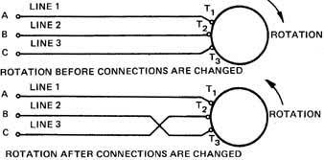

- A hydration tank has a single-phase 8000W heater, the voltage to the tank is changed from 400VAC to 200VAC, what is the amount of current the heater should pull at full load?
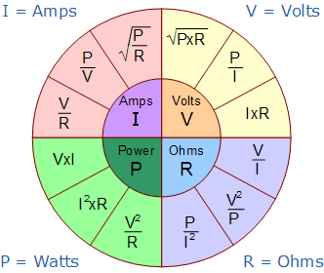
  - 80A
  - 40A
  - 20A
  - 16.67A

- What is used to measure the resistance between two point in a circuit?
  - Voltmeter
  - Ammeter
  - Ohmmeter
  - None of the above

- An oven heater rated at 750W as the oven cools the resistance of the heater changes from 7.5 ohms to 30 ohms. What is the current draw at the highest temperature?

  - 100A
  - 25A
  - 10A
  - 5A

- A non-clamp ammeter is connected ___________ to get a current reading.
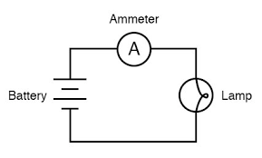
  - In parallel
  - In series
  - A low resistance meter

- An “infinite” reading (10 megohms or higher) on a coil shows ____________.
  - A good coil
  - A grounded coil
  - An open coil
  - A short-circuited coil

- To measure amps in a motor with a clamp-on amp meter, you should __________.
  - Measure each leg separately
  - Measure all three legs at the same time
  - Measure each leg to ground
  - None of the above

- On the OHMS scale, which is a higher reading?
  - 00.00
  - OL
  - The same
  - None of the above
- The secondary of a transformer is ____________.
  - The input
  - The output
  - Both a and b
  - None of the above

- An amp meter measures ___________.
  - Capacitance
  - Current
  - Resistance
  - Potential difference

- A voltmeter measures ____________.
  - Capacitance
  - Current
  - Resistance
  - Potential difference

- An ohm meter measures ____________.
  - Capacitance
  - Current
  - Resistance
  - Potential difference

- A transformer has 400 turns in the primary and 200 turns in the secondary. If 240VAC are applied to the primary winding; what voltage will be measured on the secondary winding?
  - 480VAC
  - 240VAC
  - 200VAC
  - 120VAC

- The transformer in question 28 is an example of a _____________.
  - Step up transformer
  - Auto transformer
  - Step down transformer
  - Full wave rectifier

- A 20KΩ resistor in parallel with a 20KΩ resistor produces:
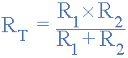
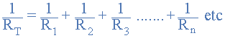
  - 10KΩ
Or
  - 5KΩ
  - 40KΩ
Note: if two resistors in parallel are the same value, Rt = ½ R1 or R2. Rt = (20KΩ) * 0.5
  - None of the above
- Battery supplies _________ current.
  - Positive
  - Negative
Note: Direct Current (DC)
  - Direct
  - Alternating

- On a 120VAC 60Hz system, what is meant by hertz?
  - Amps
Note: The hertz (symbol: Hz) is the derived unit of frequency in the International System of Units (SI) and is defined as one cycle per second.
  - Watts
  - Cycles
  - Impedance

- An RTD is ____________.
  - Response time detector
Resistance thermometers, also called resistance temperature detectors (RTDs), are sensors used to measure temperature. Many RTD elements consist of a length of fine wire wrapped around a ceramic or glass core but other constructions are also used. The RTD wire is a pure material, typically platinum, nickel, or copper.
  - Real time detector
  - Resistance thermal device
  - Regenerative transference device

- In a transformer, the winding connected to the supply voltage is called ___________.
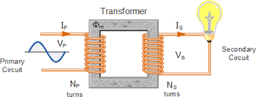
  - Primary winding
  - Secondary winding
  - Multiple winding
  - Transformer winding

- A capacitor is _____________.
  - A device that limits current flow
A capacitor is a device that stores electrical energy in an electric field. It is a passive electronic component with two terminals. The effect of a capacitor is known as capacitance.
  - A device that can store electric charge
  - Used to measure the charge in a battery
  - Used to measure capacity of motors

- A series circuit is ___________.
A series circuit is a circuit in which resistors are arranged in a chain, so the current has only one path to take. The current is the same through each resistor.
  - Many circuits from the same source
  - Used for sensing open circuits
  - A circuit having only one path
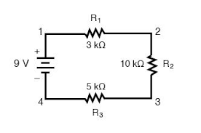
  - All the above

- An electric solenoid is ________.
  - A solid-state device
https://youtu.be/BbmocfETTFo

  - A single ground detector
  - A coil of wire with a movable magnetic core
  - None of the above

- The purpose of a GFCI is to ___________.
  - Provide a high resistance to ground in wet locations
  - Increase the trip time of the protective device (breaker or fuse) in wet locations
  - Detect small amounts of leakage current and quickly trip
https://youtu.be/Vkd43t2y2to

  - Provide voltage for a short time during a power outage

- A soldering iron with a three-prong cord has the insulation on the cord cut so the bare wire is showing. The proper method to repair this is _____________.
Replace the cord or discard the soldering iron
  - Double wrap with ½ overlap voltage rated electrical tape
  - Double layer of heat-shrink tubing
  - 1/8” coating of “Plasi-dip”
  - None of the above

- What is the voltage measured between the ground and neutral wires of a 120VAC system?
  - 120VAC
  - 240VAC
https://youtu.be/P-W42tk-fWc
  - 480VAC
  - 0.0VAC

- A 20KΩ resistor in series with a 20KΩ resistor produces:
  - 10KΩ
Rt = R₁ + R₂ + R₃ + ...
  - 5KΩ
  - 40KΩ
  - None of the above

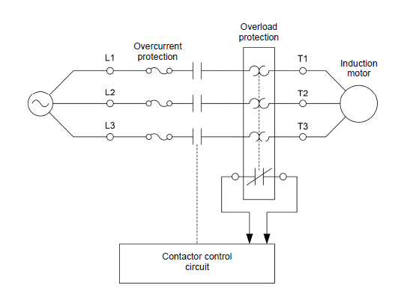

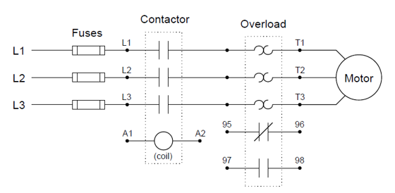

Practical Test

Understand this schematic
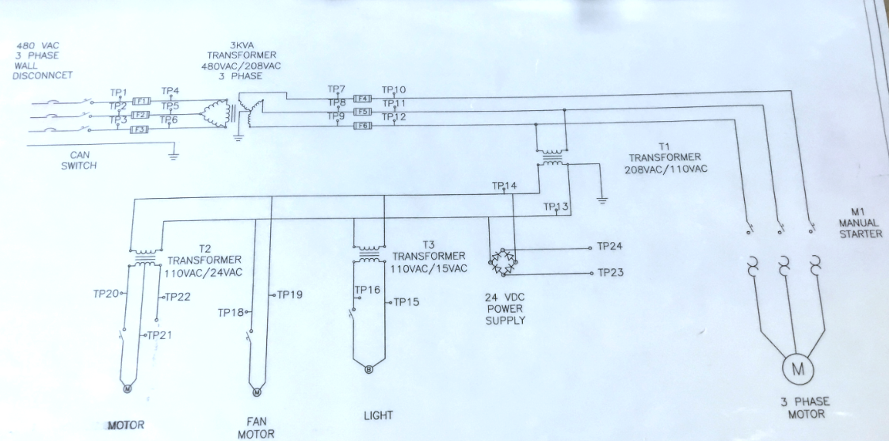

What to do before opening an electrical cabinet:
- Obtain applicable PPE
- Inspect PPE before use
  - Know the Lab coat rating and ensure it is suitable for the task
- Assess the work area for potential safety issues

